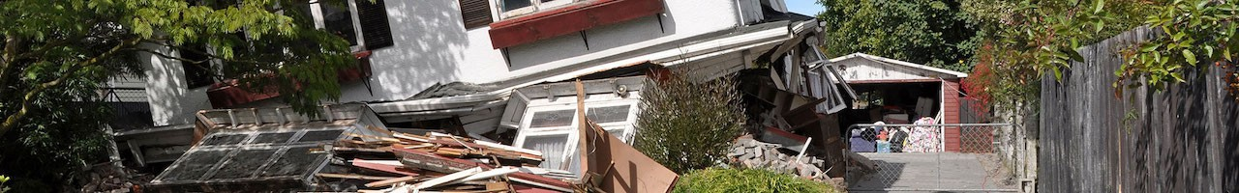
WHAT ARE YOU GOING TO DO AFTER AN EARTHQUAKE OR OTHER MAJOR DIASTER?
Hopefully, Be Prepared!
Sign up today for the City of Adair Village CERT (Community Emergency Response Team) Basic Training Course
The CERT Basic Training is now a blended learning course with all basic modules offered for free from the University of Utah Heath CERT Program. The online modules are well done and engaging. There is even an interactive virtual earthquake scene you can explore. Following successful completion of all basic training modules, your skills will be assessed by the Adair CERT Team during ongoing monthly training.

Modules:
CERT 2020.1.3 Unit 1.1 - Disaster Preparedness
CERT 2020.1.3 Unit 1.2 - Disaster Preparedness
CERT 2020.1.3 Unit 2 - The CERT Organization
CERT 2020.1.3 Unit 3.1 - Disaster Medical Operations Part 1
CERT 2020.1.3 Unit 3.2 - Disaster Medical Operations Part 1
CERT 2020.1.3 Unit 4 - Disaster Medical Operations Part 2
CERT 2020.1.3 Unit 5 - Disaster Psychology
CERT 2020.1.3 Unit 6.1 - Fire Safety and Utility Control
CERT 2020.1.3 Unit 6.2 - Fire Safety and Utility Control
CERT 2020.1.3 Unit 7.1 - Light Search and Rescue
CERT 2020.1.3 Unit 7.2 - Light Search and Rescue
CERT 2020.1.3 Unit 8.1 - Terrorism and CERT
CERT 2020.1.3 Unit 8.2 - Terrorism and CERT
CERT 2020.1.3 Unit 9 - Final Exam

Contact Jerry Jackson, CERT Training Program Manager at City Hall, 6030 William R. Carr Ave, Adair Village, email at adaircert@gmail.com, or call 541 745-5507 to let us know you are interested in the blended learning program. We will send you the link to get started.

