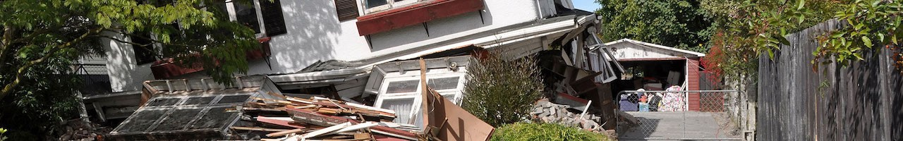
WHAT ARE YOU GOING TO DO AFTER AN EARTHQUAKE?
Be Prepared
Sign up today for the City of Adair Village CERT Course
CERT Training and Registration
Title: Cert Basic Skills Course, Course No: 21-001 (limited to 6)
Dates/Times: Wednesdays: March 24 – May 19 / 6:00 pm – 9:00 pm
Unit 1 – Disaster Preparedness 3/24
Unit 2 – CERT Organization 3/31
Unit 3 – Disaster Medical Operations – Part 1 4/7
Unit 4 – Disaster Medial Operation – Part 2 4/7
Unit 5 – Disaster Psychology & Terrorism and CERT 14/14
Unit 6 – Fire Safety and Utility Controls 4/28
Unit 7 – Disaster Psychology 5/5
Unit 8 – Light Search and Rescue Operations 5/12
Unit 9 – Course Review and Final Exam 5/19
Class locations: City Hall
Contact Jerry Jackson, CERT Training Program Manager at City Hall, 6030 William R. Carr Ave, Adair Village, email at adaircert@gmail.com, or call 541 745-5507 for more information.

