6030 William R. Carr Ave.
Adair Village, OR 97330
541-745-5507
Fax: 541-230-5219

UTILITY WORKER II
Full-time Position with Excellent Benefits

Compensation: $19.34 to $24.68 per hour
Apply by March 15, 2020 for full consideration. Position will remain open until filled.

The City of Adair Village is looking for a full-time utility worker to join a committed, seasoned Public Works staff. Adair Village is located 8 miles North of Corvallis and 8
miles Northwest of Albany. It is conveniently located off Hwy 99W and is near EE
Wilson Wildlife Area and pond but, Adair is most known for its vibrant military history.

Adair Village is welcoming new residents as it expands the number of homes in two
new developments – Calloway Creek on the South end of Adair and a smaller
development on William R Carr Street. The population of the City is expected to be
2,814 by the year 2026 which will put greater demand on current facilities and staff.

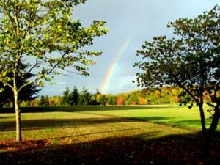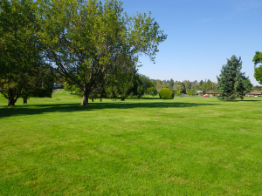

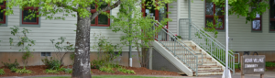

GENERAL STATEMENT OF DUTIES

- Performs a variety of semi-skilled and skilled manual tasks in the maintenance of the Cities’ streets, park, water and wastewater facilities. Operates a variety of light and heavy equipment.
- Work is performed under the direct supervision of the Public Works Supervisor.
- Supervision of other employees is not a normal responsibility of this position however; this position can act as a temporary foreman for volunteer or community service workers.

EXAMPLES OF WORK
- Maintain parks, park equipment and any other city property, this requires but is not limited to mowing, weeding, edging, garbage and debris cleanup.
- Assist in the construction, installation and repair of water and sewer lines, pumps and system components; street maintenance; grounds maintenance and mowing; and general building maintenance.
- Participate in monitoring water reservoir level, water pumps, sewage lagoon levels, sewage system pumps and lagoon irrigation system.
- Collect samples for analysis as required by water and sewer permits at the direction of the Utility Operator and obtain and record required daily systems readings.
- Service and perform minor mechanical repair on vehicles and equipment.
- Perform manual labor in loading and unloading materials and equipment.
- Operate a variety of power and hand tools including park maintenance equipment, painting equipment, oxy-acetylene torch, power saws, drills and other shop tools.
- Operate light and heavy equipment including backhoe, tractor, and other public works maintenance equipment.
- Street and curb painting.
- Some construction, plumbing, electrical, metal fabrication and welding work.
- Install, repair and maintain water meters, water mains, and fire hydrants.
- Other duties as needed.

NECESSARY QUALIFICATIONS FOR EMPLOYMENT
- A minimum two (2) years’ experience in general grounds and building maintenance.
- Current valid Oregon Driver’s License.
- Previous experience servicing and maintaining vehicles and equipment, including performing minor repairs.
- Thorough working knowledge of the tools, equipment and materials used in a public works maintenance operation. Experience in the effective and safe operation of public works maintenance equipment.
- Ability to perform strenuous manual tasks, lift one hundred (100) pounds and withstand exposure to a variety of inclement weather conditions.
- Ability to follow oral and written instructions and to communicate effectively.
- Ability to perform basic arithmetic computations.
- Ability to establish and maintain effective working relationships with other City employees and the general public.

PERFERRED EXPERIENCE AND TRAINING

- Previous municipal public works experience in water and wastewater field.
- Water or wastewater certifications or training.

