BEFORE THE CITY COUNCIL FOR THE
CITY OF ADAIR VILLAGE, OREGON

In the Matter of Amending the )
City of Adair Village’s Urban Growth )
Boundary by Adding One Property Comprising )
Of Approximately 0.12-acre West of the Calloway )
Creek Subdivision located on the SE corner of )
Ryals Avenue & Hwy. 99W. )

ORDINANCE NO. 2023-07

WHEREAS, Adair Village has grown considerably from 870 people in 2006 to 1,416 people in 2022; and

WHEREAS, the Oregon Revised States (ORS) 197.296 and the Oregon Administrative Rules (OAR) 660-015-0000 (14) require Oregon cities to maintain a 20-year land supply for housing; and

WHEREAS, the development of over 200 homes in the last three years has substantially depleted the city’s 20-year supply of buildable land.

WHEREAS, the 0.12-acre piece of property was inadvertently left off the PC22-01 UGB Expansion and this is primarily just a map adjustment to the 55 acres brought into the city earlier this year; and

WHEREAS, on July 18, 2023, the Adair Village Planning Commission conducted a duly noticed public hearing regarding Planning File Legislative Amendment PC23-04, an application by the City of Adair Village regarding an amendment to the city and county zoning maps and the Adair Village Comprehensive plan to expand the Urban Growth Boundary, that of which will be zoned residential; and

WHEREAS, on July 18, 2023, both the County and City Planning Commissions voted and recommended approval to the City Council and Board of Commissioners of the UGB expansion and amendments to the zoning map and comprehensive plan; and

WHEREAS, the Benton County Board of Commissioners and the Adair Village City Council noticed and held their respected public hearings on September 5, 2023, and based on the findings of fact and conclusions of law incorporated herein by reference, voted unanimously to approve the adoption of the UGB expansion and the accompanying zoning map/comprehensive plan amendments.

NOW, THEREFORE, THE CITY OF ADAIR VILLAGE ORDAINS AS FOLLOWS:

- The City Council of the City of Adair Village does hereby amend the Zoning/Comprehensive Plan Map’s Urban Growth Boundary to include the property lines depicted in Exhibit A and more particularly described in Exhibit B.

- The City Council of the City of Adair Village does hereby amend the Zoning/Comprehensive Plan Map to the residential land use designation on 0.12 acres of property shown in Exhibit A.

- The City Council hereby adopts the Justification and Findings document and conclusions of law of case file# PC23-04 set forth in Exhibit C in support of this UGB Expansion Ordinance as presented.

- The City Council does hearby request interim Benton County zoning designation of UR-50 to be placed on the 0.12 acre property, as shown in Exhibit A.

- The Planning Official shall make such changes to the City of Adair Village Comprehensive Plan and Map as are required to implement this amending ordinance.

Section 6: Severability. Should any section or portion of this Ordinance be held unlawful or unenforceable by any court of competent jurisdiction, such decision shall apply only to the specific section, or portion thereof, directly specified in the decision. All other sections or portions of this Ordinance shall remain in full force and effect.

Section 7. Effective Date. Passed by the City Council and approved by the Mayor of the City of Adair Village this 5th day of September 2023, the Adair Village Comprehensive Plan and Zoning Map Amendments shall become effective on October 5, 2023.

CITY OF ADAIR VILLAGE

__________________________________
MAYOR

______________________________________
CITY ADMINISTRATOR
Approved as to Form:

____________________
City Attorney

First Reading: September 5, 2023
EXHIBIT A

Proposed UGB Expansion Map
SE corner of Ryals Avenue & Hwy. 99W
0.12 Acres

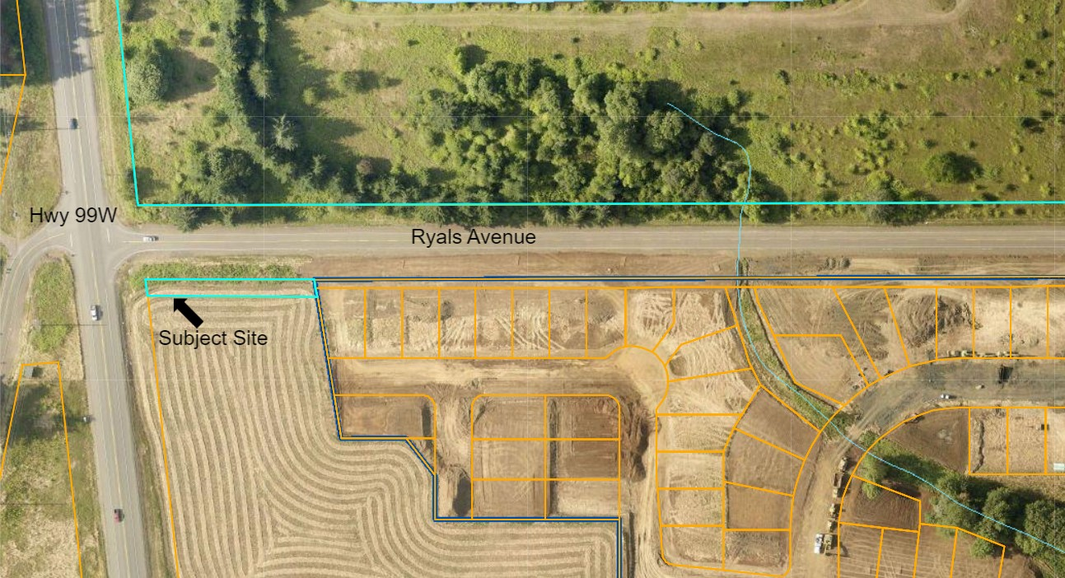

EXHIBIT B

Legal Descriptions:

Property 1: Assessment Map & Tax Lot No. 104300001400. 0.12 acres located on the south side of Ryals Avenue at the SE corner of Ryals & Hwy. 99W. The 0.12-acre piece is proposed for residential development.
EXHIBIT C

See attached:

- Adair Village & Benton County Comprehensive Plan & UGB Amendment: Justification and Findings Document – December 2022- Final Report
- Staff Report – September 5, 2023 - City Council Meeting

